- Create storage account
  - Create container
- Create Azure DB workspace
  - Launch workspace
  - Click to Catalog -> External Data
        - Click on Credentials
        - Create External locations
  - Click on new catalog
    - Create schema
    - Create volume, and upload the documents

- Go to workspace, click on ‘Create’ -> new folder

Login to Azure Databricks -> go to Storage account, open your storage account
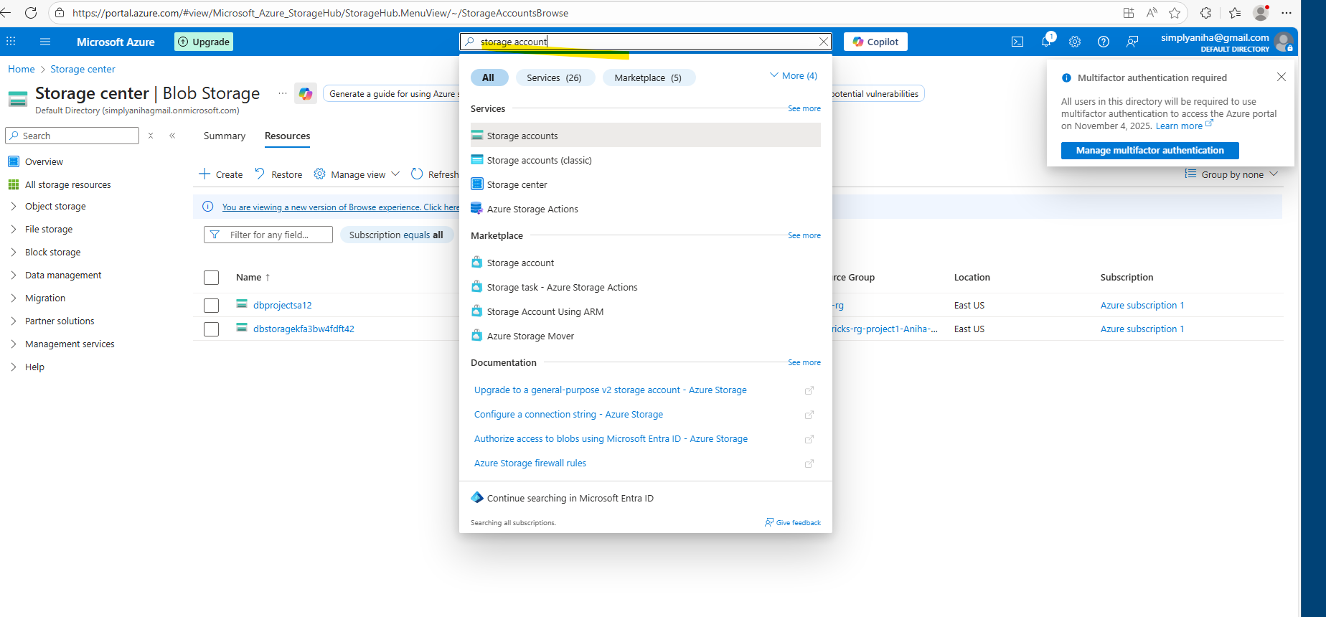

Select your storage account, click on storage account that you created
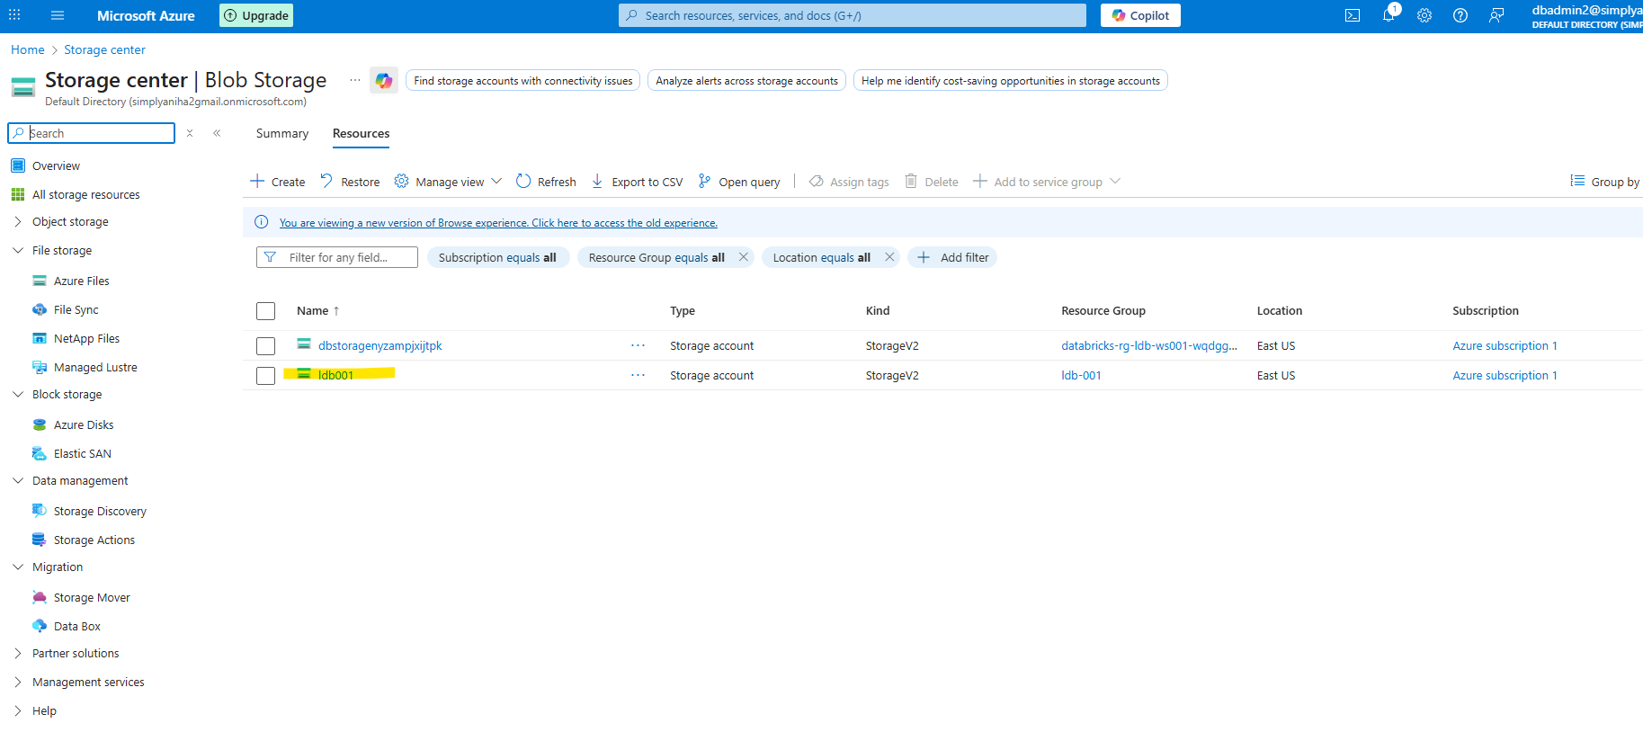

Need to create new container ‘llm’
Click on containers Add container, enter the name of container and then ‘Create’.
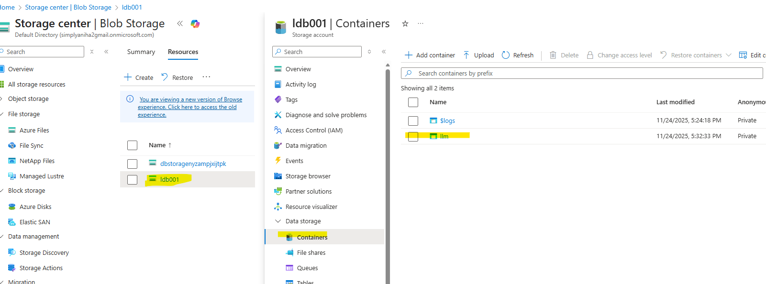
2. Launch Azure DB workspace.
From Overview, Click on Managed Resource Group
Click on Unity Catalog Access Connector, Copy the resource ID

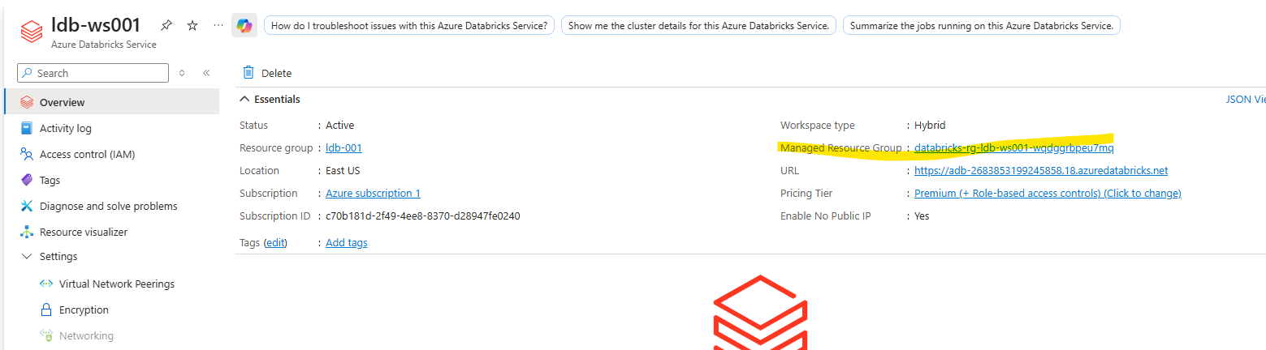
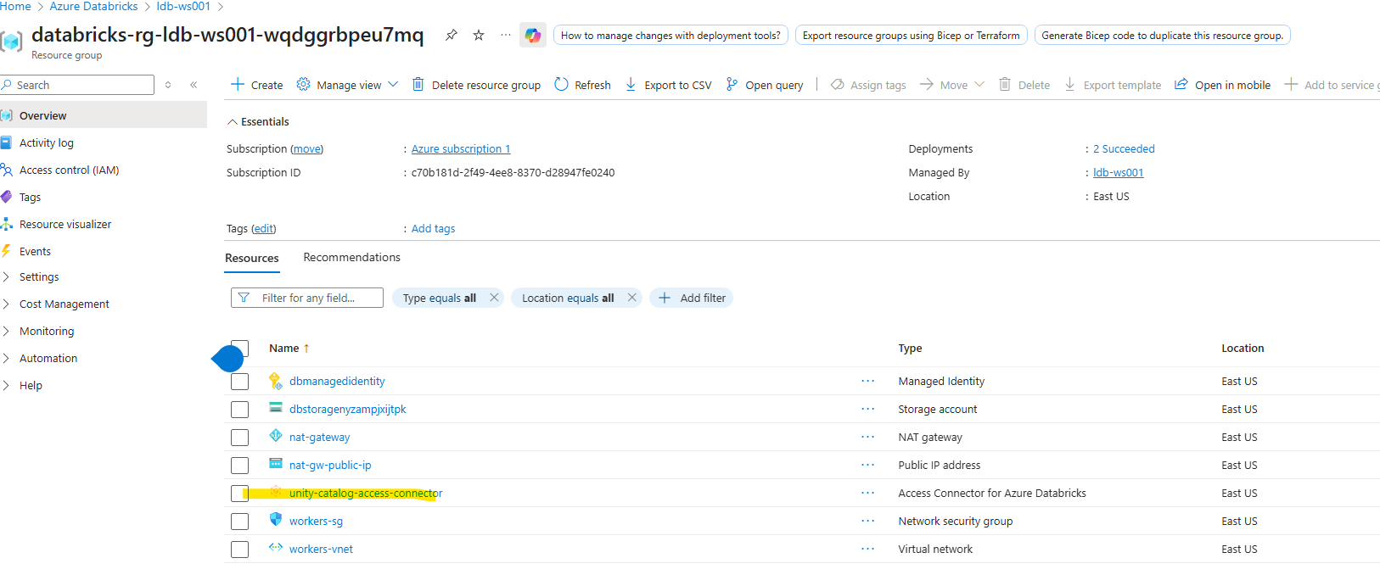
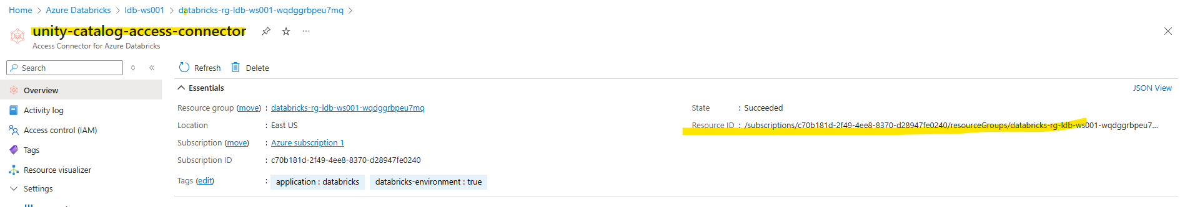

- Open workspace, create Credentials

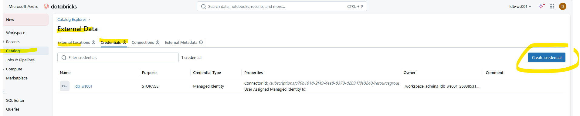
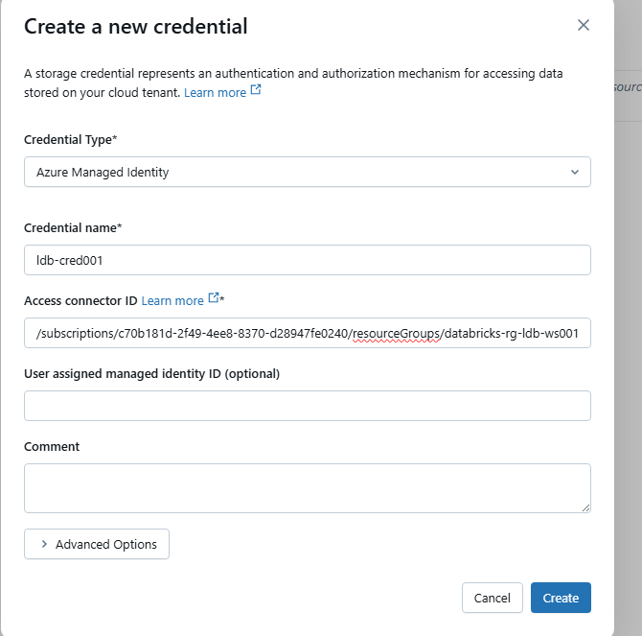
New credential has been created.
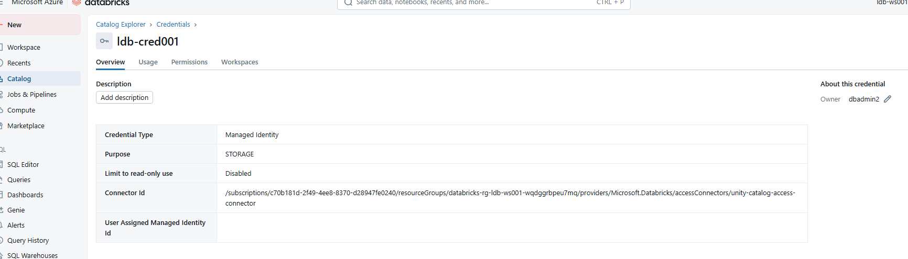
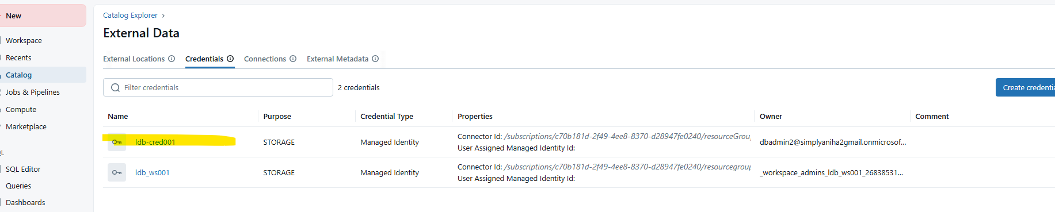

4.1. Create external location
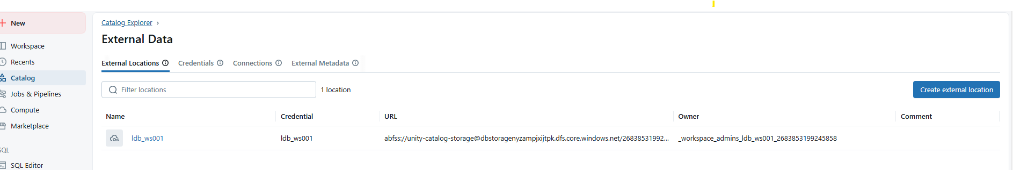

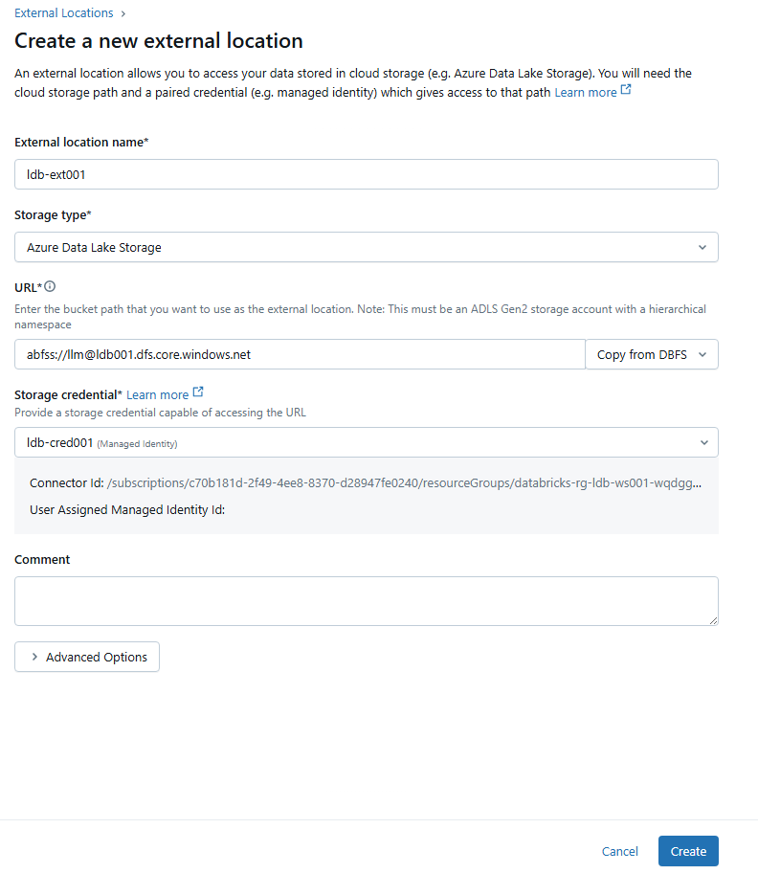
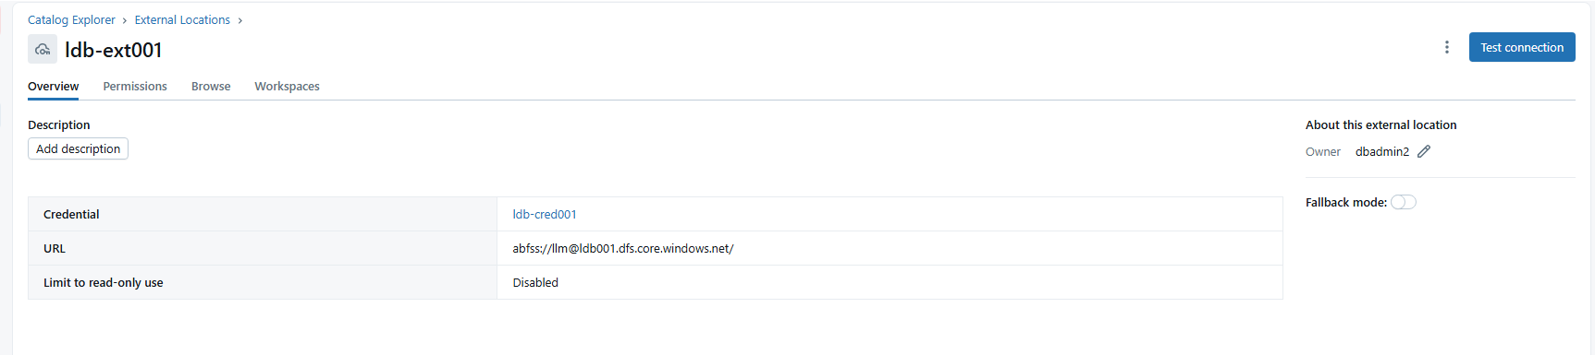
4.3. Create Catalog: ldb-cat001
Create new schema ‘RAG’
Under new schema, create a volume.

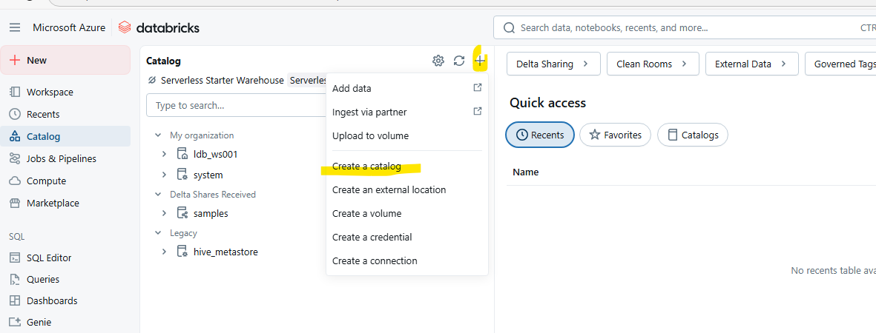

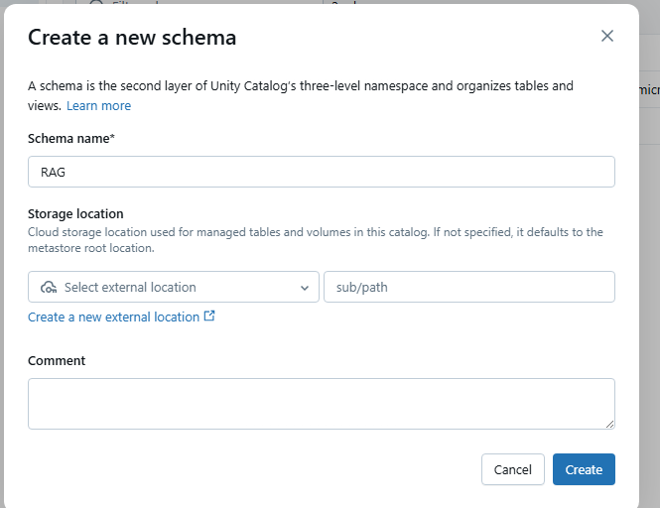
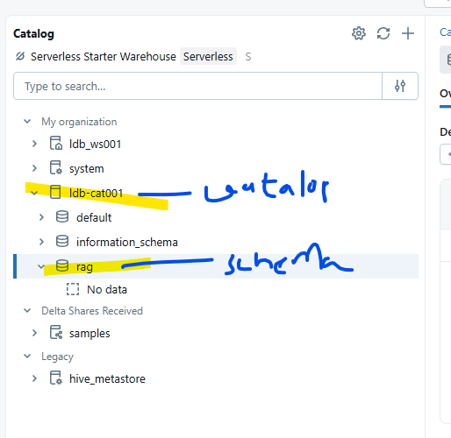

Under catalog ‘ldb-cate001’, under schema ‘rag’, create a volume called ‘rag-pdfs’
Then upload to the volume
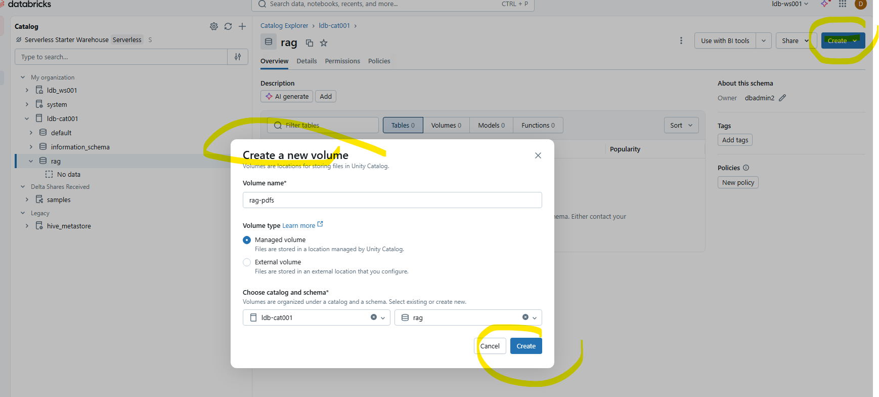
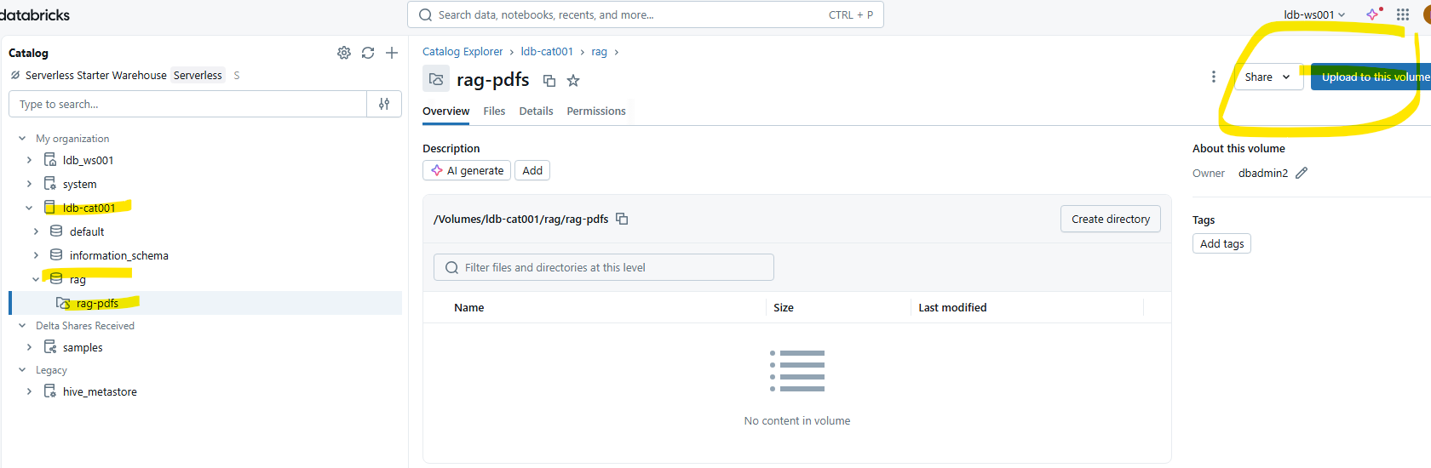
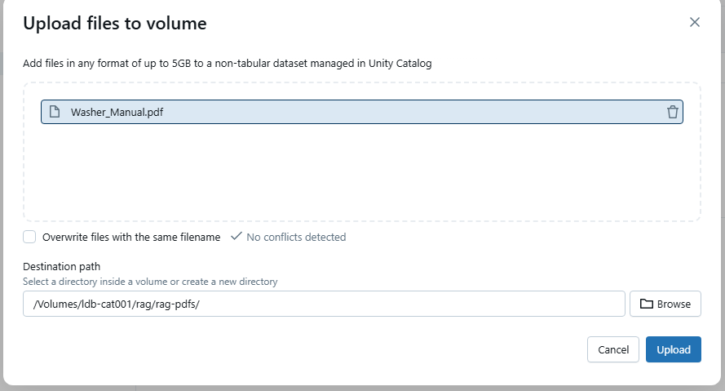
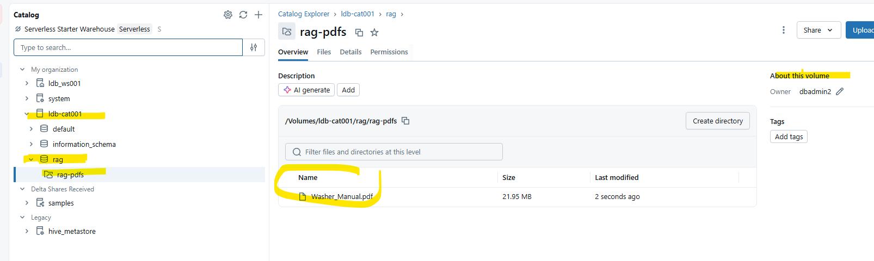

5.

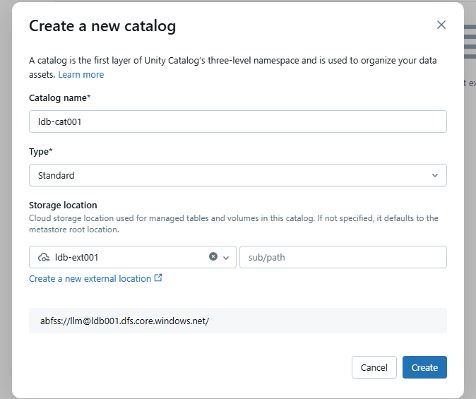
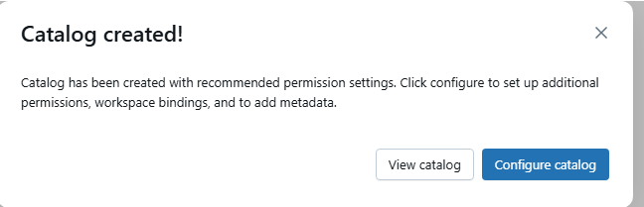
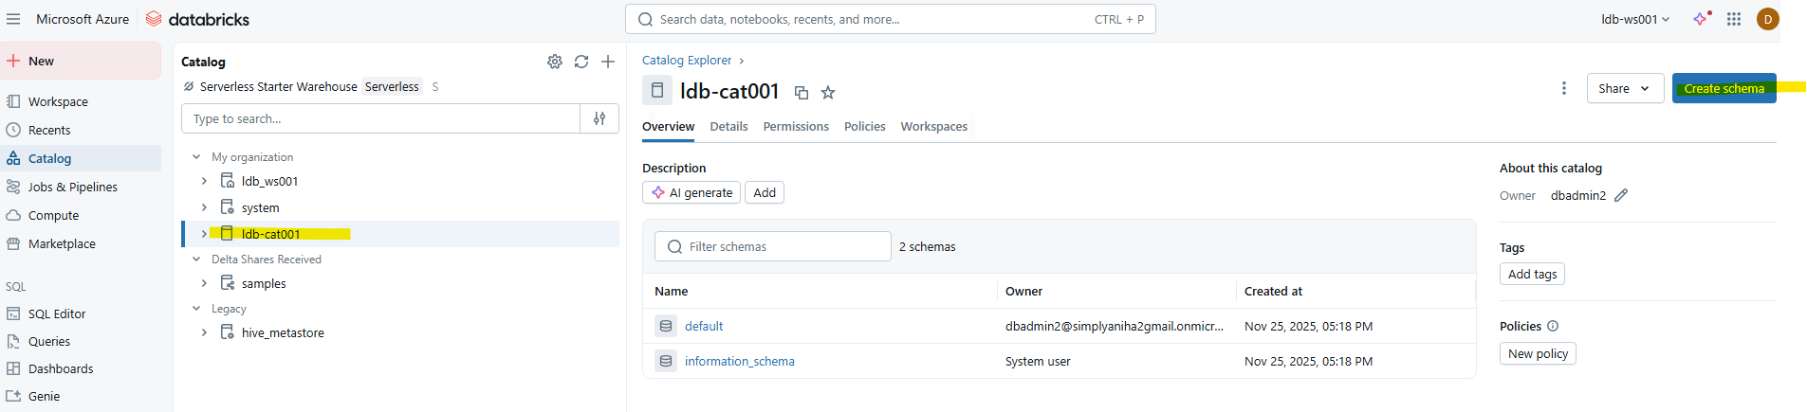

- Go to workspace, click on new folder ‘p4’.

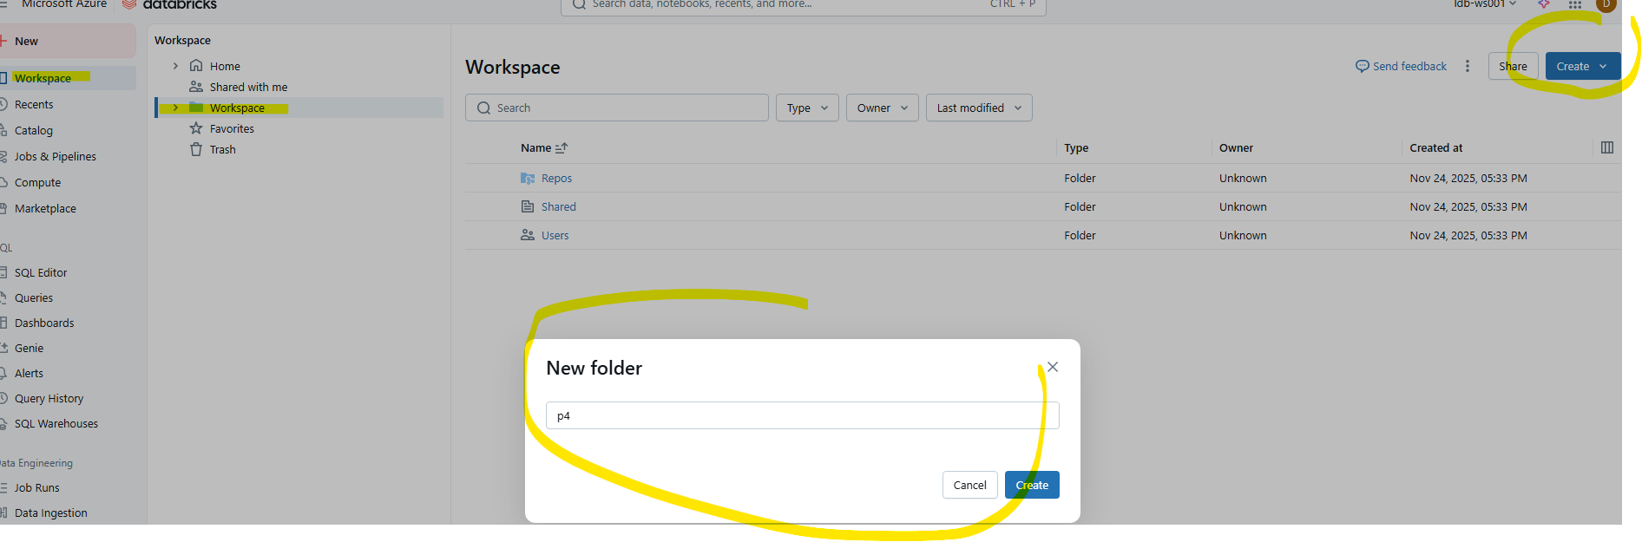

Import dbc file
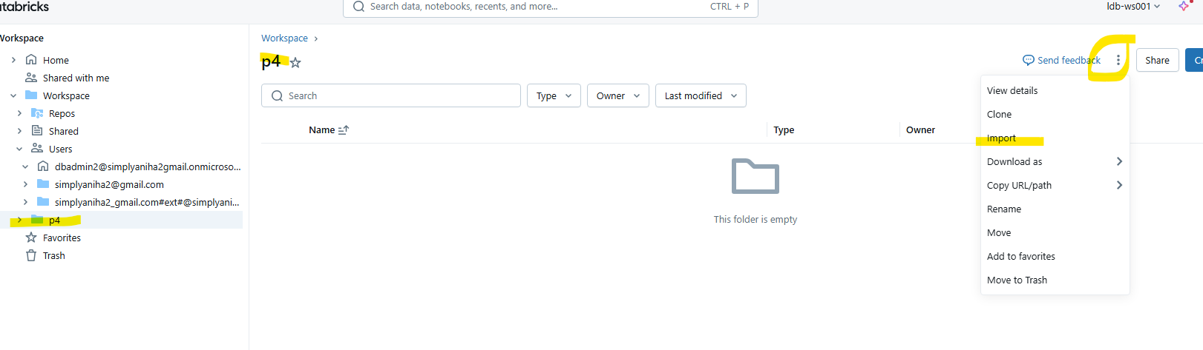
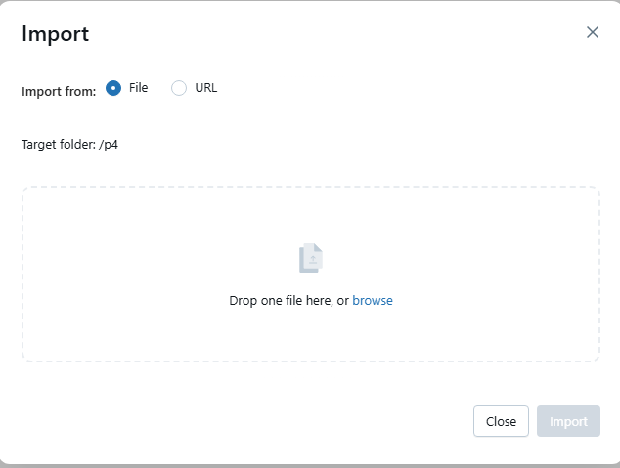
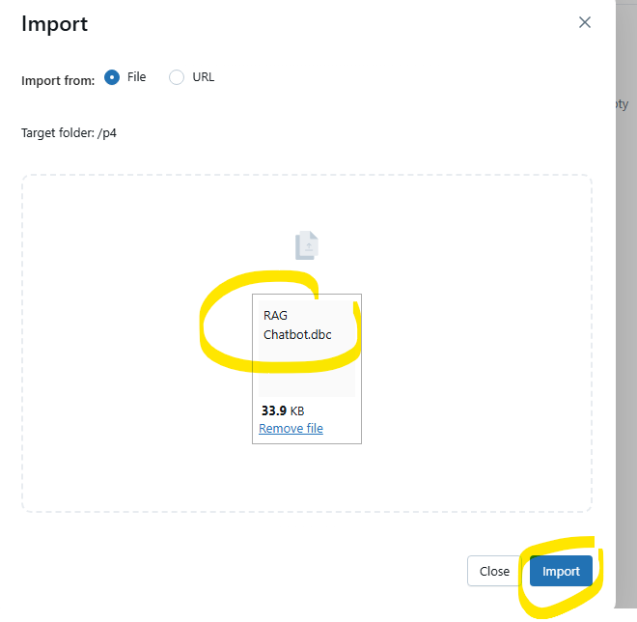
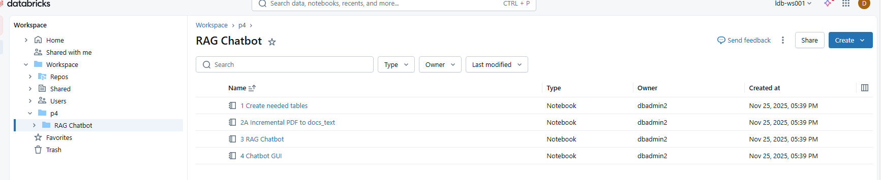
Note that all the notebooks are imported.

Run these notebooks one after another..
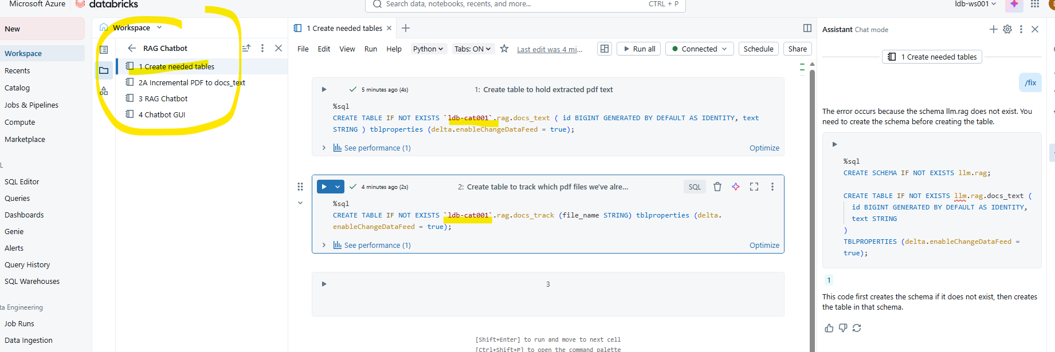

For the 2nd notebook, using pdfplumber package to extract the text.
Need langchain to interact with embedding models.

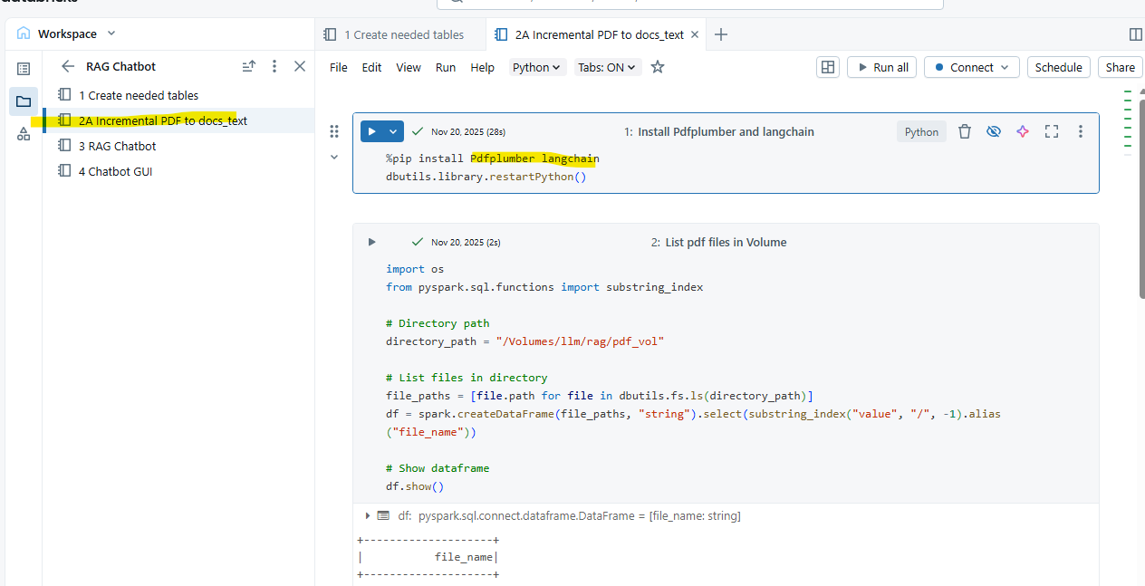
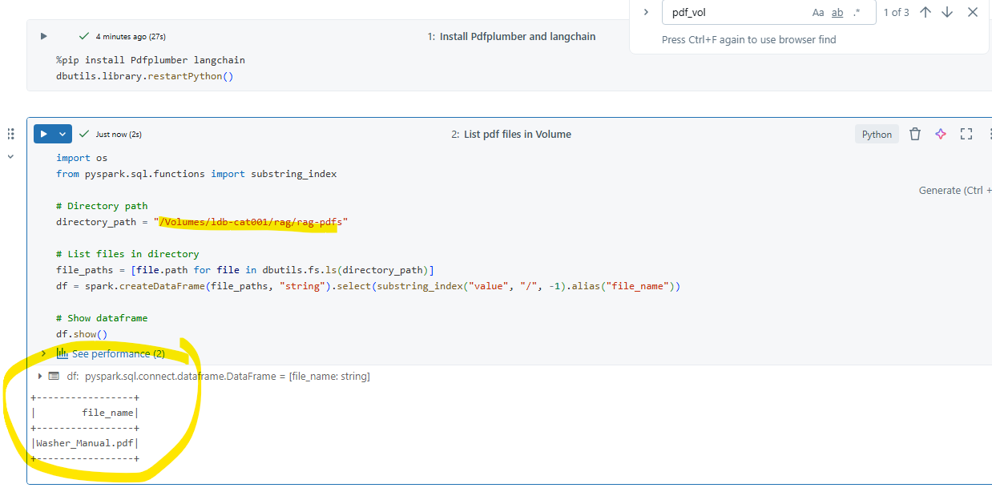
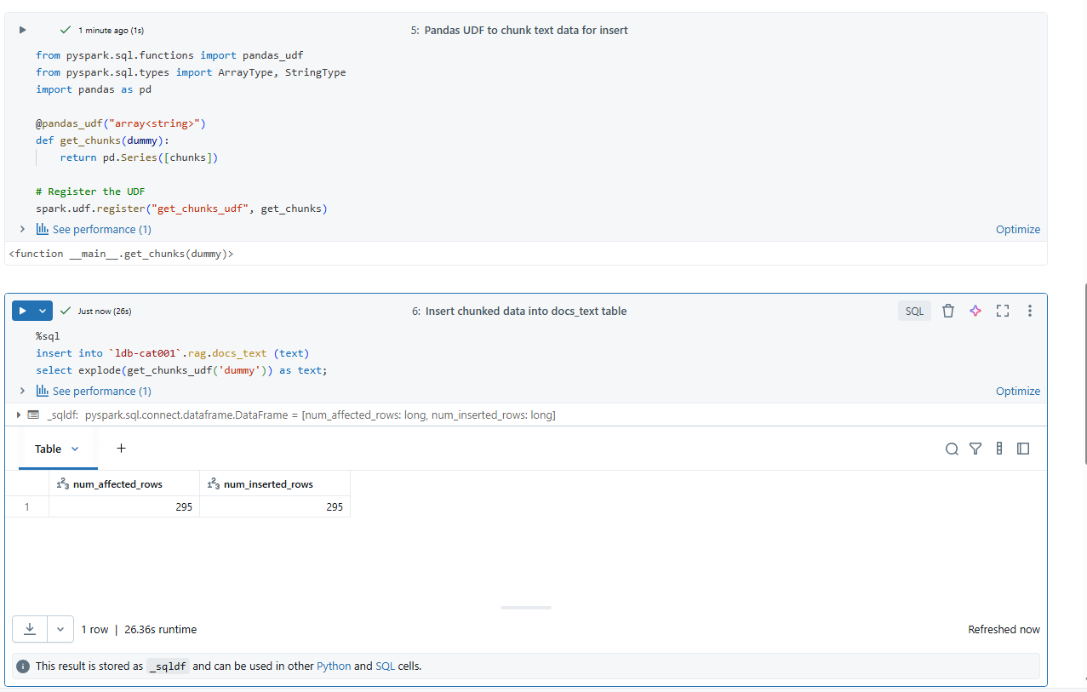
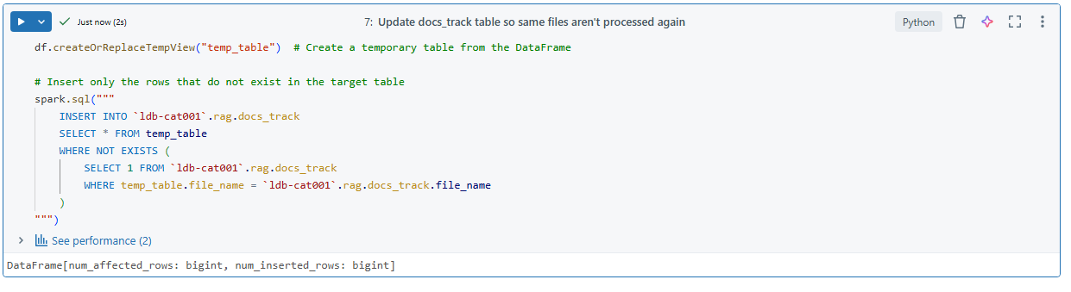

Check the data in tables
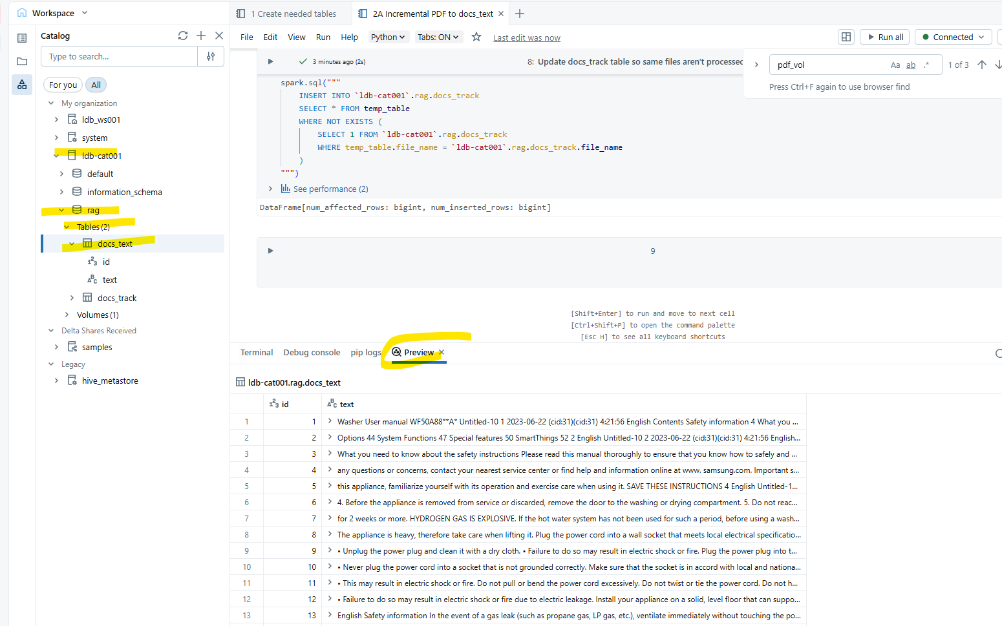

After 1 and 2nd notebook, create scope. Refer to P4-Raw.pdf

Create keyvault
